NATIONAL ECONOMICS UNIVERSITY
FACULTY OF MATHEMATICAL ECONOMICS

MAJOR ASSIGNMENT
Course: Deep Learning
TOPIC:

Instructor:
Students:

Hanoi, October 2026
Part 1: Theory
Present the theoretical background of Convolutional Neural Networks (CNNs).
Part 2: Practical Application
I. Problem Description
- Title:
- Research objectives:
- Input of the problem:
- Output of the problem:
- Provide a summary of the tasks performed for this problem.

II. Dataset Description
- Provide the download link for the dataset.
- Describe the dataset: The number of images in the dataset, the types of objects included in the images (such as vehicles, animals, medical images, etc.), and the size of each image.

III. CNN Model Design
- Preprocess the data: clean, normalize, and augment the data.
Split the dataset into three subsets and specify the number of samples in each:
- Training data (used to train the model)
- Validation data (used to tune and verify the model)
- Test data (used to evaluate the model).

- Design your own simple CNN model using convolutional, pooling, and fully connected layers to solve the given problem. Present and illustrate the architecture of your proposed CNN model. Example:
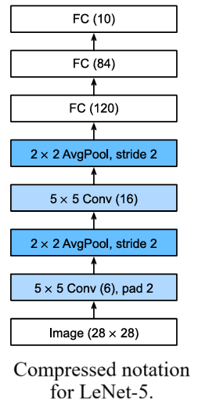
- Design your own complex CNN model using CNN blocks, convolutional, pooling, and fully connected layers to solve the given problem. Present and illustrate the architecture of your proposed CNN model. Example:

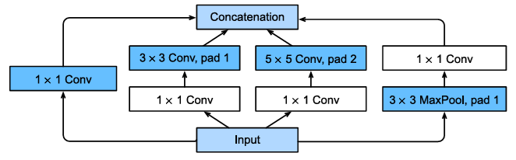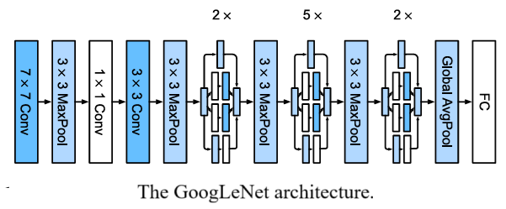

- Design a CNN model using Learning/Fine-Tuning to perform the given task. Present and illustrate the architecture of the proposed model. Example:

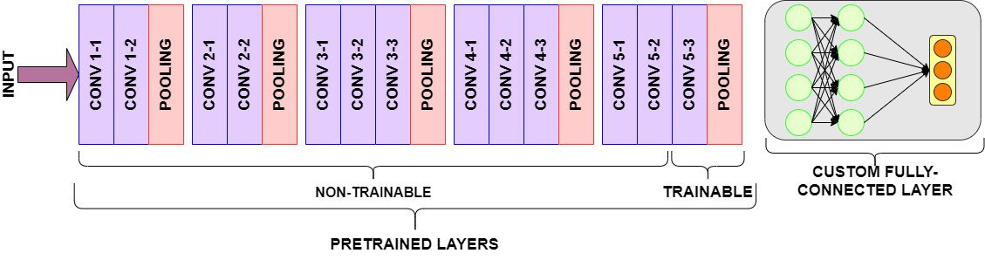

IV. Experimental Results
Evaluate the performance of the models on the test set. For example,
Model | Accuracy | Precision | Recall | F1-score
CNN
CNN+Aug+Trans

V. Conclusion
Summarize the main results achieved by the team.
References
List all references used in the report.

